**Feedback on Aspects of the Website**

**Booking Lessons Page**

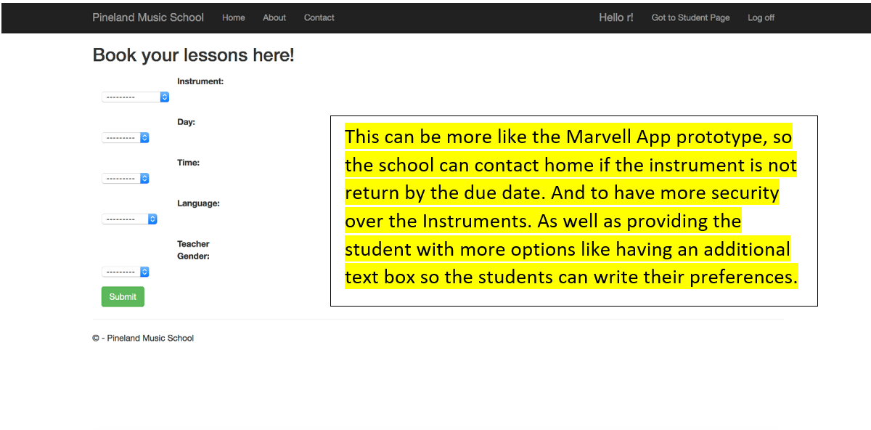

**Marvell App Booking Prototype**

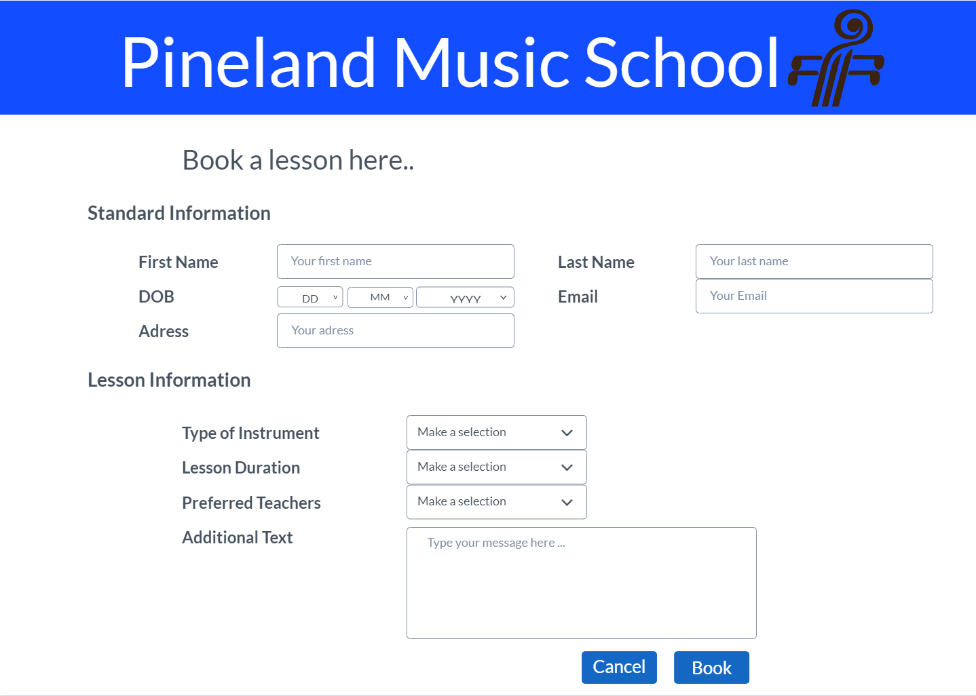

**User Profile Page**

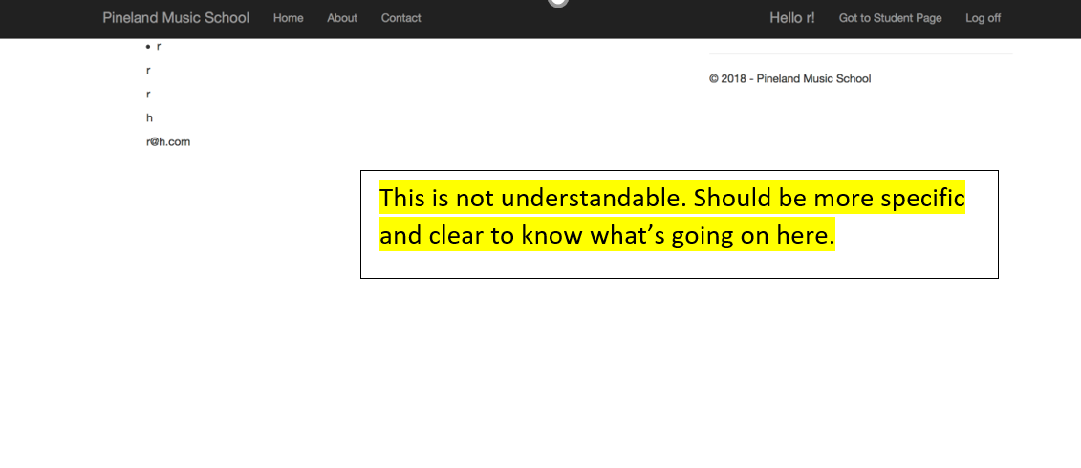

**Student Signup Page**

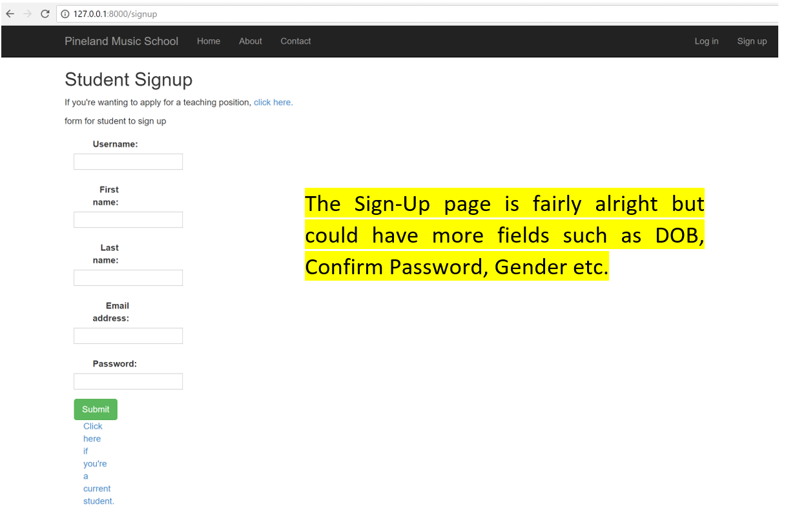

**Improvements on Feedback has been made:**

**Student Profile:**

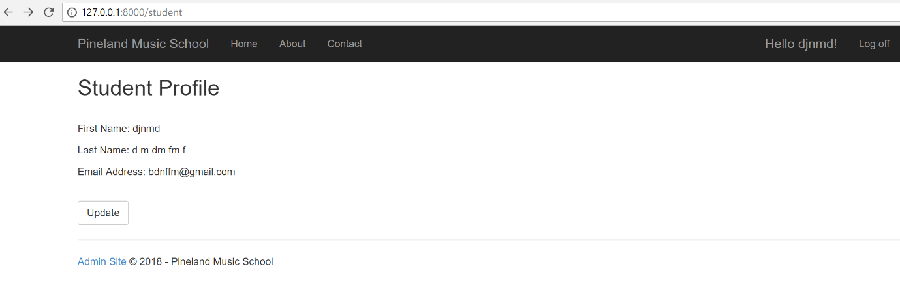

**Sign Up Page:**

